Merit Lilin Knowledge based Article for
C4 NVR Setup

Document Number：LA00002
Date：1/28/15
Dept: Technical Support, America
Subject: This document describes the setup of a NVR on Composer.
- Open up Composer.
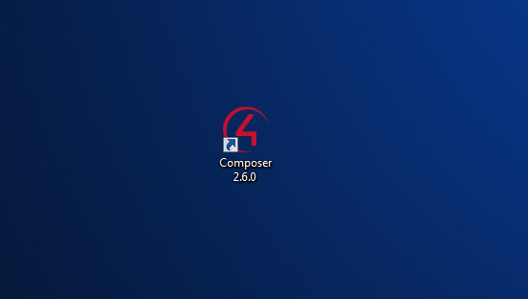
- Connect to the Local System.
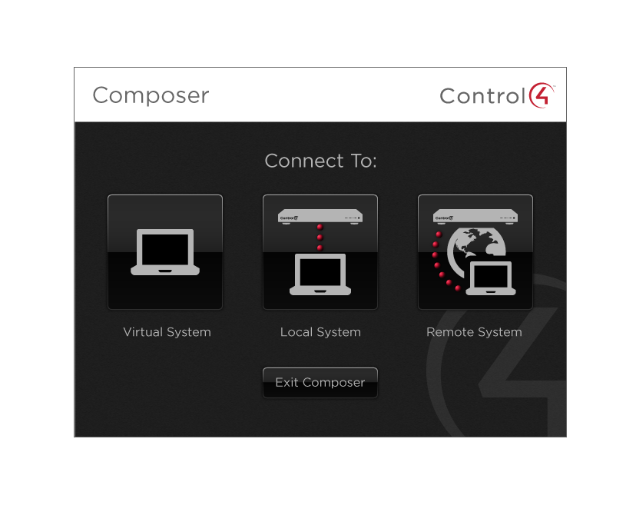
- After opening Composer, Check the section on the right. There is a box called Items.
- On the Items box there should be four tabs. The four tabs are Locations, Discovered, My Drivers, and Search.

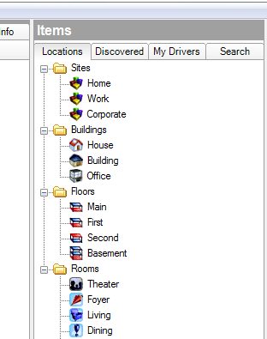
- For Automatic Setup, click on the Discovered Tab.
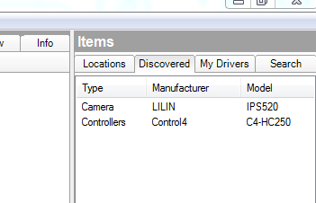
- There is a list of Lilin products under the Tab. If your NVR is listed under here, double-click on the Model of your NVR. This will input the NVR to the system design which will be able to be configured in Composer.
- For Manual Setup, click on the Search Tab.

- There is a text box under the Search Tab. Enter the Model name of the Lilin product. If your NVR is listed under here, double-click on the model of your NVR. This will input the NVR to the system design which will be able to be configured in Composer.

- Now that you setup the NVR drivers on the Composer, you can begin adjusting the Features.

- The Features should be listed in the Middle of the Composer window. There are three tabs called Properties, Documentation, and Lua. The properties tab contains all of the adjustments for the NVR.
